Task Manager Tasks to Field Task Manager
Object Sequence Diagram
@startuml
Participant “Task Manager” as TM
Participant “Field Task Manager” as FTM
TM -> FTM: Create(TM Tasks incl Task Id)
FTM -> FTM: Create FTM Tasks for contiguous region
FTM -> FTM: Map TM Tasks to FTM Subtasks>
loop for each non-contigious region
FTM -> FTM: Create FTM Tasks for contiguous region
FTM -> FTM: Map TM Tasks to FTM Subtasks
end

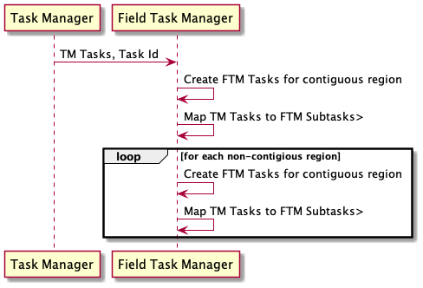
@enduml

